**Online Shopping Project**

1. It is the home page. Any user can see this (without login/signup).On clicking every icon a frame opens up like drop down.

Header consists of

* Logo
* A bar comprising of men, women, electronics icon that open up to frames
* Comparison button
* Search bar
* Profile button
* Wish list icon
* Cart icon

Footer consists of Contact us:

Centre Front End:

1. Logo will appear on every page and on clicking the logo icon it returns back to home page.
2. On clicking Men Icon opens up a frame like a drop down from where user can select various options.

Men will have two categories :

* Clothing
* Shirt
* T-shirt
* Jeans/Trouser
* Footwear

1. On clicking Women Icon opens up a frame like a drop down from where user can select various options.

Women will have two categories:

* Clothing
* Tops
* T-shirt
* Jeans/Trouser
* Footwear

1. On clicking Electronics Icon opens up a frame like a drop down from where user can select various options.

It will have:

* Mobiles
* Earphones
* Laptops

1. Comparison button: To compare login/signup is must for the user. User can compare up to four products of a single category. – To be decided
2. Search bar – results into the searched product category
3. Profile – open up a drop down having:

* Login/Signup – if not logged in
* Orders
* Wish list
* Profile

1. Wish list – Comprising of the products willing to buy. The product number will not get reduced if product is added to wish list.
2. Cart Icon – It is the bag of items selected to buy. Unless you buy it will be shown there. The product number will not get reduced if product is added to bag. Product number is reduced only on buying the product.
3. Center Part will comprise the categories in an image format. And on clicking the same we get the results.

* Men Shirts
* Men Trousers/Jeans
* Women Tops
* Women Trousers/Jeans
* Men Footwear
* Women Footwear
* Laptop
* Mobiles

1. On the click of Contact us – opens up a page of helpline numbers and mail.
2. Centre part will also have brands name with a particular discount on them.
3. Also the product image display under the header part
4. Login Page:

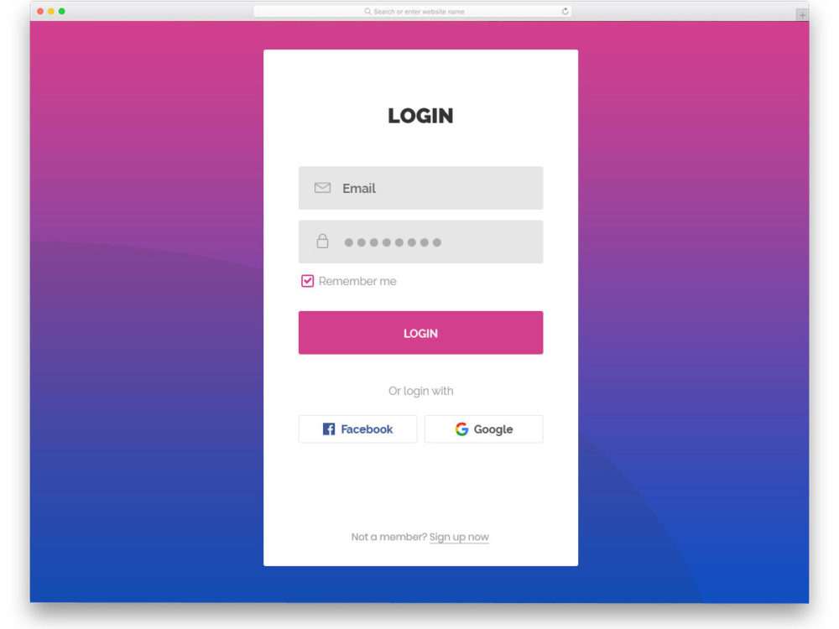

1. Signup Page:

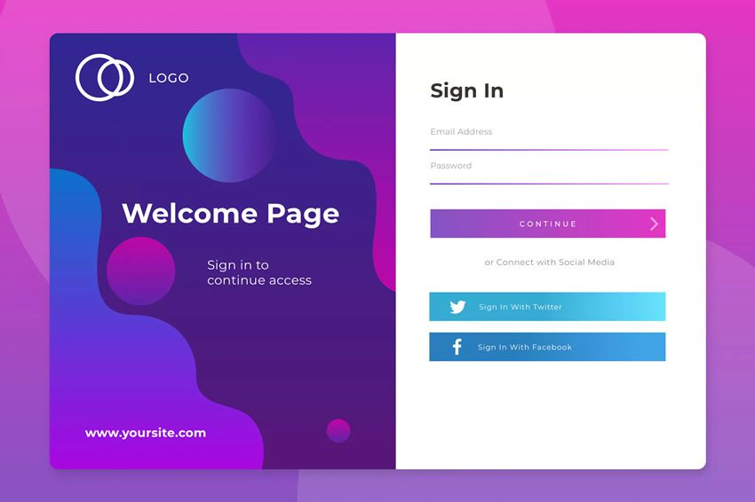

//verification too (OTP)

1. We can give logout button to log off beside the cart icon.
2. Forgot password:

Header

Pop up window – Ask for registered email/phone

Then OTP and new password.

1. Suppose I search for jeans

It will show me the available jeans. Left side will have filters (price/brand/color/) and sort(price/latest). Header and footer remains the same.

1. After logging in, username appears in place of profile.
2. Suppose I select a jeans Jeans:

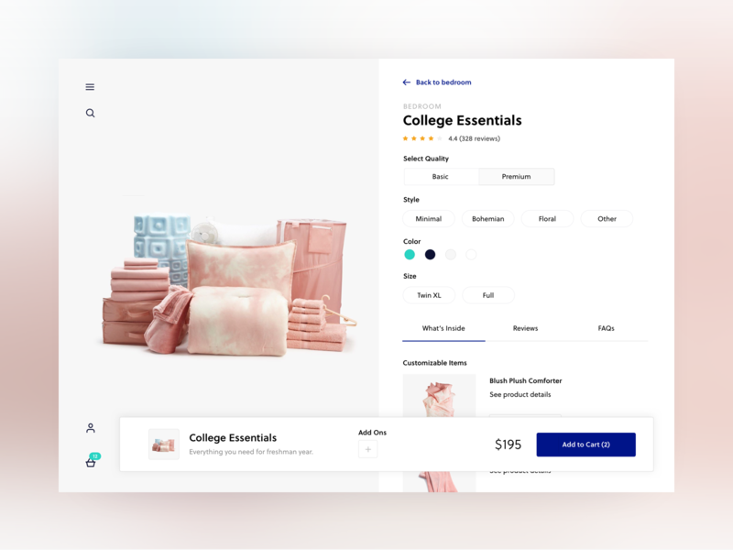

Two buttons: Add to cart/wish list

1. Cart Page:

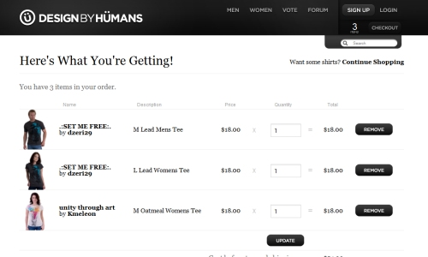

Pop to remove: move to wish list / remove completely

1. Wish list Page:

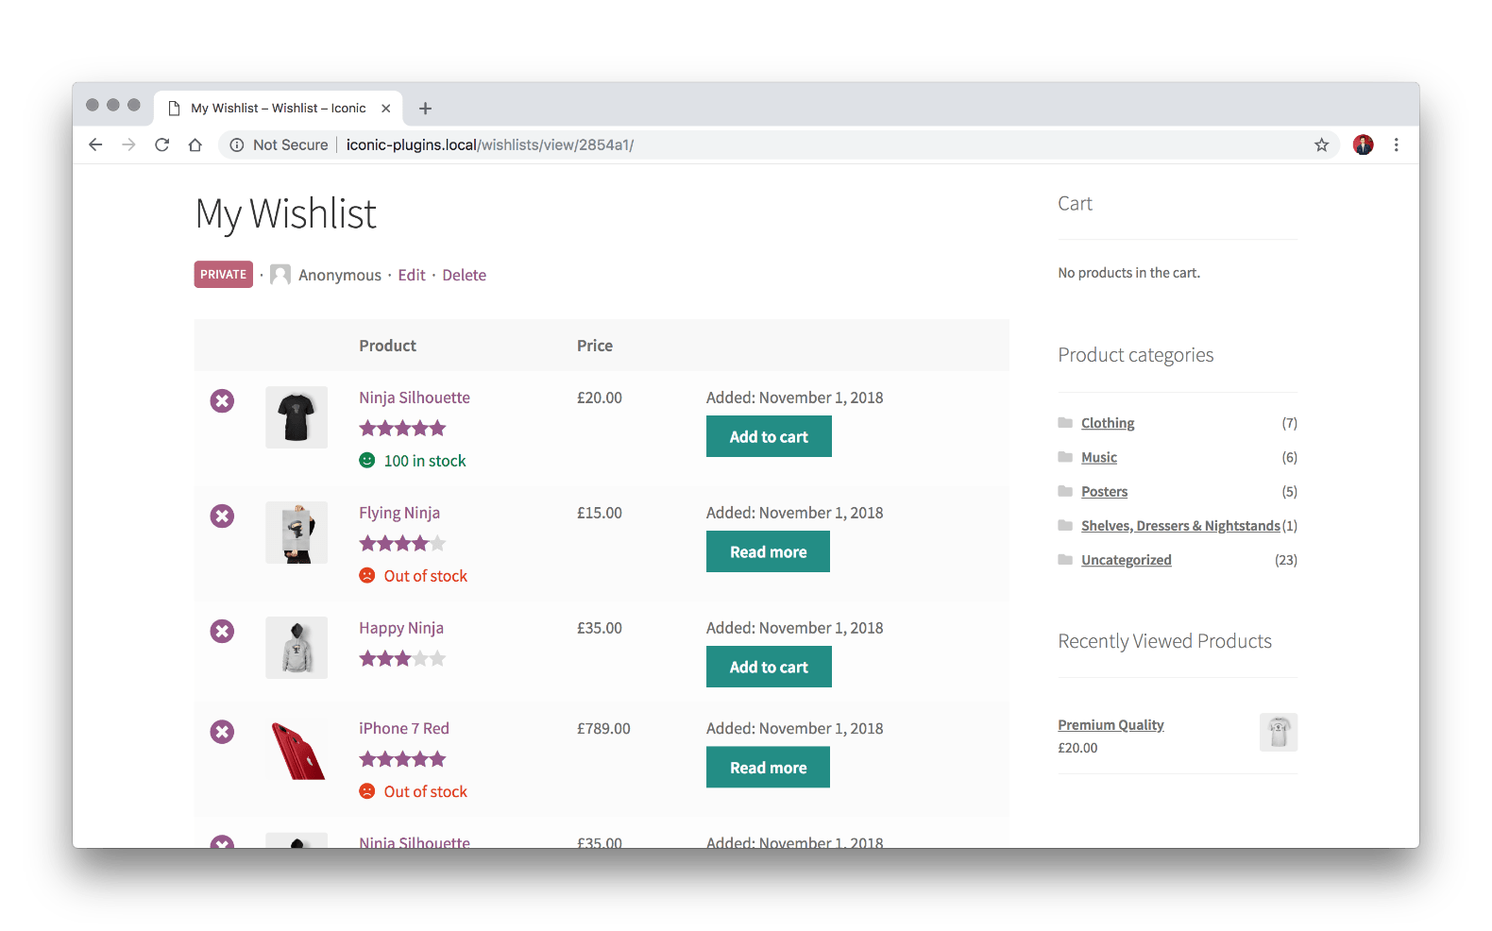

1. User Profile Page:

It consists of

* User details- full name, mail, phone with edit button
* Orders
* Cart
* Wish list

1. Users:

* Customer can only add thing to cart or wish list or buy them.
* Retailer can edit the product price and quantity(refer pdf for page)

--different UI(Only products, to add, view, update)

* Admin can edit the price and quantity (refer pdf for page). Admin can also add the product. (Product name, image, price, quantity sizes )It also handles the retailers.

1. BreadCrumbs

**Database : db_OnlineShopping**

**Tables:**

1. **Customer Login Table**
2. **Admin Login Table**
3. **Retailer Login Table**
4. **Payment table**
5. **Orders Table**
6. **Orders Detail Table**
7. **Category Table includes brand**
8. **Category Type Table**
9. **Product table**
10. **Wishlist**

**Table 1: Customer Login Table (CustomerLogin):**

Customer Id : cust_id (int){Auto increment}[primary key – to differentiate]

Customer Name: cust_name (varchar)

Customer Phone_No: cust_phone (nvarchar)-default

//Customer Gender: cust_gender (varchar)//

Customer Email: cust_mail (nvarchar)

Customer Password: cust_password (nvarchar) - encryption - for security

Customer Address: cust_address (nvarchar) – to fetch at the time of placing the order

**Table 2: Admin Login Table(AdminLogin):**

Admin Id : admin_id (int){Auto increment} [primary key – to differentiate as name can be same]

Admin Name: admin_name (varchar)

Admin Password: admin_password (nvarchar) - encryption - for security

**Table 3: Retailer Login Table(RetailerLogin):**

Retailer Id : ret_id(int){Auto increment}[primary key – to differentiate]

Retailer Name: ret _name(varchar)

Retailer Phone_No: ret _phone(nvarchar)-default

Retailer Email: ret _mail(nvarchar)

Retailer Password: ret_password(nvarchar) - encryption - for security